SUPPLY LIST FOR INCOMING FRESHMEN

CLOTHING ITEMS

Start of school through October 1:
Dress Shorts (solid color) with belt
Polo style shirts, socks and athletic shoes

October 1 through Mid-May:
Dress Shirts (collared)
Neckties, bowties
Dress Slacks, with belt
Appropriate shoes in good condition, socks

Additional:
Please refer to the handbook section: DRESS CODE AND PERSONAL APPEARANCE for a more detailed account of allowed clothing.

Sport coat or suit will be required for formal events
P.E. shorts and shirt are required.

SCHOOL & MISC. SUPPLIES:
Notebooks Pencils Calculator (scientific will be needed later)
Notebook paper Pens Backpack
3-ring binder Erasers Travel size facial tissues to keep in backpacks
Folders Highlighters (assorted) Other items needed for personal academic success

BAND/CHOIR/STRINGS: Practices are in the morning at 7 a.m. Please bring your musical instrument.

BOOKSTORE: MM apparel, snacks, notebooks, Bible, pens and toiletry items are also available for purchase.

DAY STUDENTS:
One locker is assigned in the upstairs freshmen locker room area for PE/athletics (in addition to your school locker). Locks are not provided. Please label your lock if you choose to have one with your name and give your dean the combination written down on a 3 x 5 index card with your name on it.

BOARDING STUDENTS:
Freshmen are assigned to rooms with a maximum of six people. Three bunk beds and six large lockers are provided. No other furniture (couch/chair) is allowed in these rooms as they are not designed as hangout spaces. We want freshmen to interact and integrate with as many different people as possible in the designated common areas.

BEDDING/PERSONAL ITEMS
Pillow/pillowcase
Sheets - one set- twin size (Mattresses are either 74” or 80”) You can use a sleeping bag the first night of orientation if you want to wait to see what size mattress he will have.
Comforter/bedspread, blankets - 1-2
Laundry bag/basket - large
Bath size towels
Toiletry items and caddy (soap, shampoo, deodorant, toothbrush, toothpaste, etc.)
Box of facial tissues to keep at their desks
Alarm clock

CLOSET SPACE: each boarder will have one 2’ x 6’ locker available to hang their clothes. Small bins/baskets are useful to store socks, shorts and other items on the shelves of the locker, above and below. Each locker has a lockable compartment. Locks are not provided and those who wish to bring out a lock must make sure his dean has the combination.

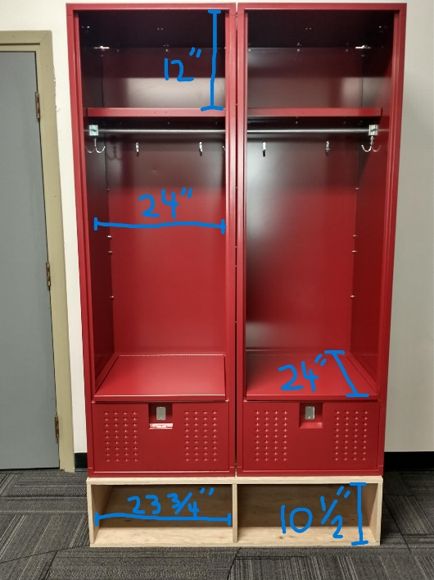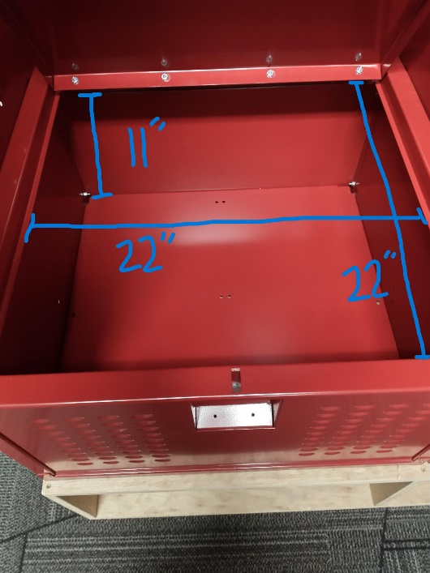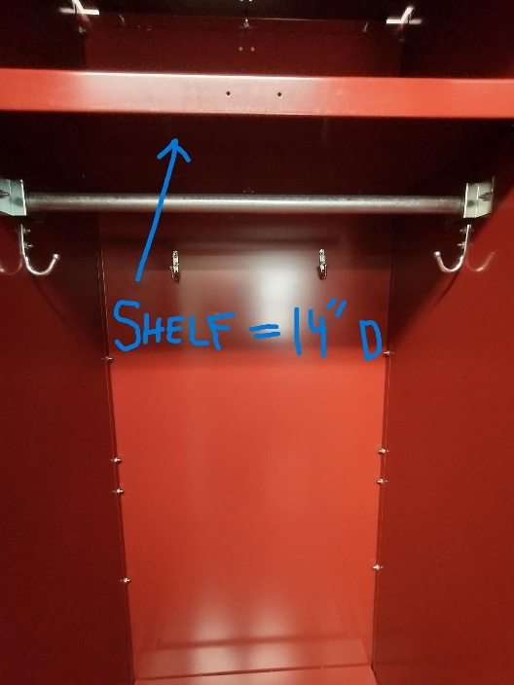

Each 6-person room is allowed to have ONE REFRIGERATOR (4.5 cu ft max). It is best to coordinate this after everyone has moved in.

